Mike Solomon Meeting:

* Landed Cost: Advise on how to do this.
  + Use expected load shipping cost field on PO form.
  + They know what the expected load shipping cost.
    - Pull value from expected load shipping cost field on PO to the Freight in field. Cost allocation method should be weight.
    - Need calculated field on PO to step down remaining load shipping cost.
    - Total pounds on PO field and pounds field on the line level.
    - Expose item weight field on item and enter weight value.
    - One PO could have multiple item receipts.
    - Item receipts are coming in via integration (Celigo). Can do manual item receipts.
    - Sometimes load shipping cost could be NULL.
  + Potentially look at a custom table to store expected load shipping cost and auto populate based on that table. Karsten has the details.
  + 6D02/ 6D04

Coterie is looking to use landed cost in their process, but are looking for a way to streamline the process to make it less labor intensive and error prone.

Part of this will require the creation of one or more custom tables, some custom fields and scripting. Please see below for details regarding the configuration.

**Custom Fields:** The following custom fields have been created on the purchase order form:

* Total PO Weight: custbody_coterie_total_po_weight
* Total Line Weight: custcol_coterie_total_line_weight
* Expected Load Shipping Cost: custbody7
* Remaining Load Shipping Cost: custbody_coterie_remain_load_ship_cost
* Total Weight IR: custbody_cot_total_weight_ir
* Total Line Weight IR: custcol_cot_total_line_weight_ir

**Scripts:** When they create a purchase order, they will be entering a value in the Expected Load Shipping Cost field on the PO form. This represents the total landed cost for the entire purchase order.

Script 1: The first script will need to populate the line level weight fields with a value of qty x weight (from that item record).

The header level weight field will need to be populated based on the sum of the line level weight fields.

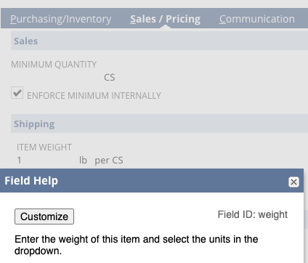

When they do an item receipt, they will want the Landed Cost to be automatically populated onto the item receipt based on the volume of items being received from that purchase order.

Script 2:

The item receipt will have line level weight fields just like the PO and a header level weight field just line the PO.

The line level weight field should be populated with a value of qty x Weight (from that item record).

The header level weight field should be populated based on the sum of the line level weight fields.



They can have multiple item receipts from a single purchase order, so based on the weight of items being received, that needs to be compared to the total weight of the purchase order and then, based on the percentage of the weight, that percentage of the Expected Load Shipping Cost will be added to the item receipt as Landed Cost.

Script 3:

Take the value from the header level total weight field and compare that to the total weight from the purchase order to determine the percentage. Use this percentage value to determine the percent of the Expected Load Shipping Cost that should be added as landed cost on the item receipt.

This landed cost amount that was determined in the previous step should be populated in this field on the item receipt.

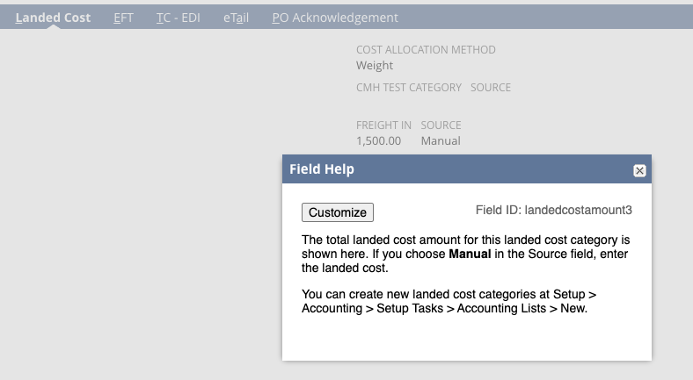

Example:

* The purchase order has an Expected Load Shipping Cost of $5,000.
* The Total Purchase Order Weight is 100 pounds.
* The Item Receipt is 25 Pounds
* 25 pounds is 25% of the 100 pounds, so we would add 25% of the $5,000 to the item receipt ($1,250).